Lab 3

Yousef Jarrar, Jose Perez

CSE 461 – Dr. Tong Yu

**Part I: Basics – Create Hello World App**

We followed the instructions that were provided to us in the Android guide posted on Dr. Yu’s website. It provided a step by step instruction on how to use the IDE and the development of the first app. It provided an insight on how to run an instance of the application and provides more than one “emulator” to run the application on. Bellow is the snippets of code used to develop the Hello World App.

**MainActivity.java**

**package** com.example.helloworld;  
  
**import** android.os.Bundle;  
**import** android.support.design.widget.FloatingActionButton;  
**import** android.support.design.widget.Snackbar;  
**import** android.support.v7.app.AppCompatActivity;  
**import** android.support.v7.widget.Toolbar;  
**import** android.view.View;  
**import** android.view.Menu;  
**import** android.view.MenuItem;  
  
**public class** MainActivity **extends** AppCompatActivity {  
  
 @Override  
 **protected void** onCreate(Bundle savedInstanceState) {  
 **super**.onCreate(savedInstanceState);  
 setContentView(R.layout.***activity_main***);  
 Toolbar toolbar = findViewById(R.id.***toolbar***);  
 setSupportActionBar(toolbar);  
  
 FloatingActionButton fab = findViewById(R.id.***fab***);  
 fab.setOnClickListener(**new** View.OnClickListener() {  
 @Override  
 **public void** onClick(View view) {  
 Snackbar.*make*(view, **"Replace with your own action"**, Snackbar.***LENGTH_LONG***)  
 .setAction(**"Action"**, **null**).show();  
 }  
 });  
 }  
  
 @Override  
 **public boolean** onCreateOptionsMenu(Menu menu) {  
 *// Inflate the menu; this adds items to the action bar if it is present.* getMenuInflater().inflate(R.menu.***menu_main***, menu);  
 **return true**;  
 }  
  
 @Override  
 **public boolean** onOptionsItemSelected(MenuItem item) {  
 *// Handle action bar item clicks here. The action bar will  
 // automatically handle clicks on the Home/Up button, so long  
 // as you specify a parent activity in AndroidManifest.xml.* **int** id = item.getItemId();  
  
 *//noinspection SimplifiableIfStatement* **if** (id == R.id.***action_settings***) {  
 **return true**;  
 }  
  
 **return super**.onOptionsItemSelected(item);  
 }  
}

**Content_Main.xml**

*<?***xml version="1.0" encoding="utf-8"***?>*<**android.support.constraint.ConstraintLayout xmlns:android="http://schemas.android.com/apk/res/android"  
 xmlns:app="http://schemas.android.com/apk/res-auto"  
 xmlns:tools="http://schemas.android.com/tools"  
 android:layout_width="match_parent"  
 android:layout_height="match_parent"  
 app:layout_behavior="@string/appbar_scrolling_view_behavior"  
 tools:context=".MainActivity"  
 tools:showIn="@layout/activity_main"**>  
  
 <**TextView  
 android:layout_width="109dp"  
 android:layout_height="102dp"  
 android:text="Hello, CSE 461-660"  
 app:layout_constraintBottom_toBottomOf="parent"  
 app:layout_constraintLeft_toLeftOf="parent"  
 app:layout_constraintRight_toRightOf="parent"  
 app:layout_constraintTop_toTopOf="parent"  
 app:layout_constraintVertical_bias="0.291"  
 tools:layout_editor_absoluteX="121dp"**/>  
  
</**android.support.constraint.ConstraintLayout**>

**Output:**

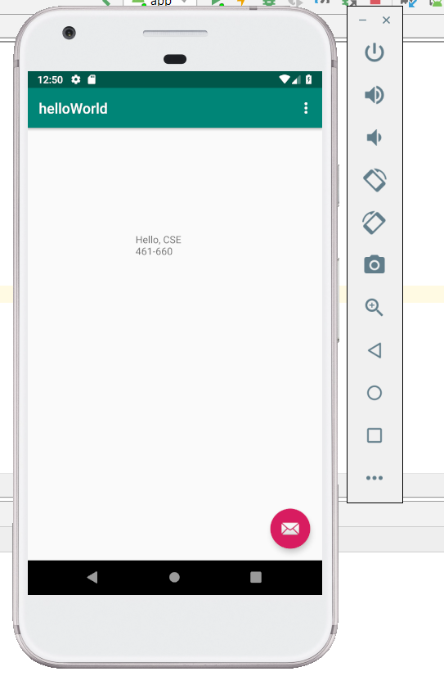

**Part II: Simple Calculator – w/Android**

The code in this section was provided by the professor’s lab manual. It provided an insight about how a calculator can be created using simple java. Although the input of the code is very complex, changes must be made to suit the needs of the virtual phone. The following is the OUTPUT we received prior to completing the assignment:

**PRIOR OUTPUT:**

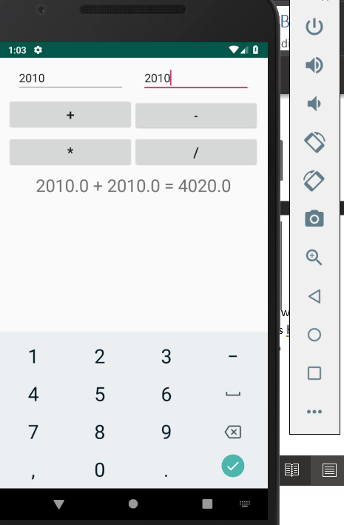

**After modifying the code:** 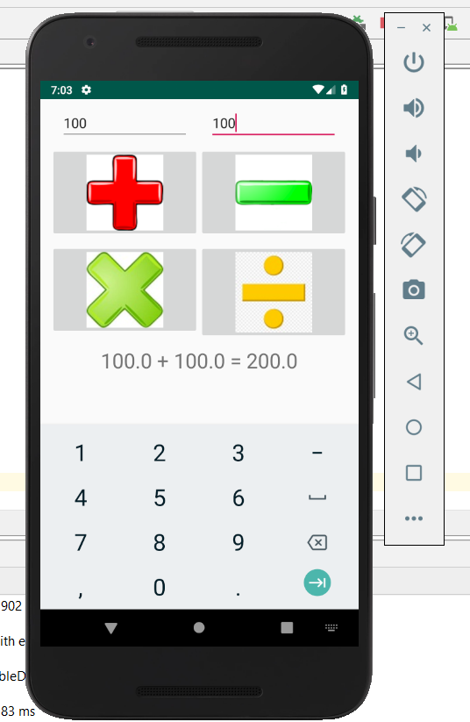

**The following files have been named: Calculator, Calculator and example.calculator and *modified***

**MainActivity.java**

**package** example.calculator;  
  
**import** android.os.Bundle;  
**import** android.app.Activity;  
**import** android.content.DialogInterface;  
**import** android.content.DialogInterface.OnClickListener;  
**import** android.text.TextUtils;  
**import** android.view.Menu;  
**import** android.view.View;  
**import** android.widget.Button;  
**import** android.widget.EditText;  
**import** android.widget.ImageButton;  
**import** android.widget.TextView;  
  
**public class** MainActivity **extends** Activity **implements** View.OnClickListener{  
 EditText **t1**;  
 EditText **t2**;  
  
 ImageButton **plus**;  
 ImageButton **minus**;  
 ImageButton **multiply**;  
 ImageButton **divide**;  
  
 TextView **displayResult**;  
  
 String **oper** = **""**;  
  
 */** Called when the activity is first created. */* @Override  
 **public void** onCreate(Bundle savedInstanceState) {  
 **super**.onCreate(savedInstanceState);  
 setContentView(R.layout.***activity_main***);  
  
 *// find the EditText elements (defined in res/layout/activity_main.xml* **t1** = (EditText) findViewById(R.id.***t1***);  
 **t2** = (EditText) findViewById(R.id.***t2***);  
  
 **plus** = (ImageButton) findViewById(R.id.***plus***);  
 **minus** = (ImageButton) findViewById(R.id.***minus***);  
 **multiply** = (ImageButton) findViewById(R.id.***multiply***);  
 **divide** = (ImageButton) findViewById(R.id.***divide***);  
  
 **displayResult** = (TextView) findViewById(R.id.***displayResult***);  
  
 *// set listeners* **plus**.setOnClickListener( **this** );  
 **minus**.setOnClickListener( **this**);  
 **multiply**.setOnClickListener( **this**);  
 **divide**.setOnClickListener( **this**);  
  
 }  
  
 *// @Override* **public void** onClick( View view ) {  
 **double** num1 = 0;  
 **double** num2 = 0;  
 **double** result = 0;  
  
 *// check if the fields are empty* **if** (TextUtils.*isEmpty*(**t1**.getText().toString())  
 || TextUtils.*isEmpty*(**t2**.getText().toString())) {  
 **return**;  
 }  
  
 *// read EditText and fill variables with numbers* num1 = Float.*parseFloat*(**t1**.getText().toString());  
 num2 = Float.*parseFloat*(**t2**.getText().toString());  
  
 *// perform operations  
 // save operator in oper for later use* **switch** ( view.getId() ) {  
 **case** R.id.***plus***:  
 **oper** = **"+"**;  
 result = num1 + num2;  
 **break**;  
 **case** R.id.***minus***:  
 **oper** = **"-"**;  
 result = num1 - num2;  
 **break**;  
 **case** R.id.***multiply***:  
 **oper** = **"*"**;  
 result = num1 * num2;  
 **break**;  
 **case** R.id.***divide***:  
 **oper** = **"/"**;  
 result = num1 / num2;  
 **break**;  
 **default**:  
 **break**;  
 }  
  
 *// form the output line* **displayResult**.setText(num1 + **" "** + **oper** + **" "** + num2 + **" = "** + result);  
 }  
}

**Activity_main.xml**

*<?***xml version="1.0" encoding="utf-8"***?>*<**LinearLayout  
 xmlns:android="http://schemas.android.com/apk/res/android"  
 android:orientation="vertical"  
 android:layout_width="fill_parent"  
 android:layout_height="fill_parent"**>  
 <**LinearLayout  
 android:layout_width="match_parent"  
 android:layout_height="wrap_content"  
 android:id="@+id/linearLayout1"  
 android:layout_marginLeft="12pt"  
 android:layout_marginRight="12pt"  
 android:layout_marginTop="4pt"**>  
 <**EditText  
 android:layout_weight="1"  
 android:layout_height="wrap_content"  
 android:layout_marginRight="6pt"  
 android:id="@+id/t1"  
 android:layout_width="match_parent"  
 android:inputType="numberDecimal"**>  
 </**EditText**>  
 <**EditText  
 android:layout_height="wrap_content"  
 android:layout_weight="1"  
 android:layout_marginLeft="6pt"  
 android:id="@+id/t2"  
 android:layout_width="match_parent"  
 android:inputType="numberDecimal"**>  
 </**EditText**>  
 </**LinearLayout**>  
 <**LinearLayout  
 android:layout_width="match_parent"  
 android:layout_height="wrap_content"  
 android:id="@+id/linearLayout2"  
 android:layout_marginTop="4pt"  
 android:layout_marginLeft="6pt"  
 android:layout_marginRight="6pt"**>  
 <**ImageButton  
 android:layout_height="wrap_content"  
 android:layout_width="match_parent"  
 android:src="@drawable/plus"  
 android:layout_weight="1"  
 android:textSize="10pt"  
 android:id="@+id/plus"**>  
 </**ImageButton**>  
 <**ImageButton  
 android:layout_height="wrap_content"  
 android:src="@drawable/minus"  
 android:layout_width="match_parent"  
 android:layout_weight="1"  
 android:textSize="8pt"  
 android:id="@+id/minus"**>  
 </**ImageButton**>  
 </**LinearLayout**>  
 <**LinearLayout  
 android:layout_width="match_parent"  
 android:layout_height="wrap_content"  
 android:id="@+id/linearLayout3"  
 android:layout_marginTop="4pt"  
 android:layout_marginLeft="6pt"  
 android:layout_marginRight="6pt"**>  
  
 <**ImageButton  
 android:layout_height="wrap_content"  
 android:src="@drawable/multi"  
 android:layout_width="match_parent"  
 android:layout_weight="1"  
 android:textSize="10pt"  
 android:id="@+id/multiply"**>  
 </**ImageButton**>  
 <**ImageButton  
 android:layout_height="wrap_content"  
 android:layout_width="match_parent"  
 android:layout_weight="1"  
 android:src="@drawable/divide"  
 android:textSize="10pt"  
 android:id="@+id/divide"**>  
 </**ImageButton**>  
 </**LinearLayout**>  
  
 <**TextView  
 android:layout_height="wrap_content"  
 android:layout_width="match_parent"  
 android:layout_marginLeft="6pt"  
 android:layout_marginRight="6pt"  
 android:textSize="12pt"  
 android:layout_marginTop="4pt"  
 android:id="@+id/displayResult"  
 android:gravity="center_horizontal"**>  
 </**TextView**>  
</**LinearLayout**>

**Please notice that we have added the images to the root folder of “drawable” so that the images populate when the application runs.**

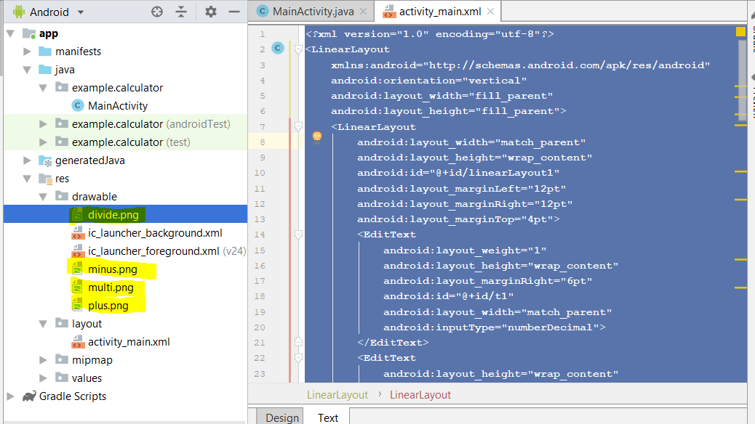

**Part III: Android Fragments**

For this portion we had to research online how to create android fragments and implement them with MainActivity.java – The hardest part about this lab was being able to understand how the buttons and the onClickActivity worked within the virtual device. We didn’t understand that within MainActivity is where it ties the click event buttons and creates the fragment view. We used the toast widget, which will notify the person that the button has been clicked.

**MainActivity.java**

**package** example.fragments;  
  
**import** android.support.v7.app.AppCompatActivity;  
**import** android.os.Bundle;  
**import** android.support.v4.app.Fragment;  
**import** android.support.v4.app.FragmentManager;  
**import** android.support.v4.app.FragmentTransaction;  
**import** android.widget.Button;  
**import** android.view.View;  
**import** android.widget.Toast;  
  
**public class** MainActivity **extends** AppCompatActivity **implements** View.OnClickListener{  
 Button **fragA**;  
 Button **fragB**;  
 @Override  
 **protected void** onCreate(Bundle savedInstanceState){  
 **super**.onCreate(savedInstanceState);  
 setContentView(R.layout.***activity_main***);  
 **fragA** = (Button) findViewById(R.id.***fragA***);  
 **fragB** = (Button) findViewById(R.id.***fragB***);  
  
 **fragA**.setOnClickListener(**this**);  
 **fragB**.setOnClickListener(**this**);  
  
 **if** (findViewById(R.id.***main_frame***) !=**null**){  
 **if**(savedInstanceState != **null**)  
 **return**;  
  
 FragmentManager fm = getSupportFragmentManager();  
 FragmentTransaction ft = fm.beginTransaction();  
 ft.replace(R.id.***main_frame***, **new** FragmentA());  
 ft.commit();  
 }  
 }  
 **public void** onClick(View view){  
 Fragment fragment;  
 **if**(view == findViewById(R.id.***fragA***)){  
 fragment = **new** FragmentA();  
 FragmentManager fm = getSupportFragmentManager();  
 Toast.*makeText*(**this**, **"Fragment A Selected"**, Toast.***LENGTH_SHORT***).show();  
 FragmentTransaction ft = fm.beginTransaction();  
 ft.replace(R.id.***main_frame***, fragment);  
 ft.commit();  
 }  
 **if**(view == findViewById(R.id.***fragB***)){  
 fragment = **new** FragmentB();  
 FragmentManager fm = getSupportFragmentManager();  
 Toast.*makeText*(**this**, **"Fragment B Selected"**, Toast.***LENGTH_SHORT***).show();  
 FragmentTransaction ft = fm.beginTransaction();  
 ft.replace(R.id.***main_frame***, fragment);  
 ft.commit();  
 }  
 }  
}

**Activity_Main.xml**

*<?***xml version="1.0" encoding="utf-8"***?>*<**LinearLayout  
 xmlns:android="http://schemas.android.com/apk/res/android"  
 android:orientation="vertical"  
 android:layout_width="match_parent"  
 android:layout_height="match_parent"**>  
 <**Button  
 android:id="@+id/fragA"  
 android:layout_width="match_parent"  
 android:layout_height="wrap_content"  
 android:text="Fragment A"** />  
 <**Button  
 android:id="@+id/fragB"  
 android:layout_width="match_parent"  
 android:layout_height="wrap_content"  
 android:text="Fragment B"** />  
 <**FrameLayout  
 android:layout_width="match_parent"  
 android:layout_height="match_parent"  
 android:layout_weight="1"  
 android:id="@+id/main_frame"**>  
 *<!-- Fragment added here onCreate -->* </**FrameLayout**>  
</**LinearLayout**>

**FragmentA.java**

**package** example.fragments;  
  
**import** android.os.Bundle;  
**import** android.support.annotation.Nullable;  
**import** android.support.v4.app.Fragment;  
**import** android.view.LayoutInflater;  
**import** android.view.View;  
**import** android.view.ViewGroup;  
  
**public class** FragmentA **extends** Fragment{  
 @Nullable  
 @Override  
 **public** View onCreateView(LayoutInflater inflater, ViewGroup container, Bundle savedInstanceState){  
 **return** inflater.inflate(R.layout.***fragment_a***, container, **false**);  
 }  
}

**fragment_a.xml**

*<?***xml version="1.0" encoding="utf-8"***?>*<**LinearLayout xmlns:android="http://schemas.android.com/apk/res/android"  
 xmlns:tools="http://schemas.android.com/tools"  
 android:orientation="vertical"  
 android:layout_width="match_parent"  
 android:layout_height="match_parent"  
 tools:context="example.fragments.FragmentA"  
 android:background="#FFFDF48D"**>  
 <**TextView  
 android:id="@+id/textView"  
 android:layout_width="match_parent"  
 android:layout_height="wrap_content"  
 android:text="I am Fragment A"  
 tools:text="I am Fragment A"  
 android:textStyle="bold"  
 android:textSize="35dp"**/>  
</**LinearLayout**>

**FragmentB.java**

**package** example.fragments;  
  
**import** android.os.Bundle;  
**import** android.support.annotation.Nullable;  
**import** android.support.v4.app.Fragment;  
**import** android.view.LayoutInflater;  
**import** android.view.View;  
**import** android.view.ViewGroup;  
  
**public class** FragmentB **extends** Fragment{  
 @Nullable  
 @Override  
 **public** View onCreateView(LayoutInflater inflater, ViewGroup container, Bundle savedInstanceState){  
 **return** inflater.inflate(R.layout.***fragment_b***, container, **false**);  
 }  
}

**fragment_b.xml**

*<?***xml version="1.0" encoding="utf-8"***?>*<**LinearLayout  
 xmlns:android="http://schemas.android.com/apk/res/android"  
 xmlns:tools="http://schemas.android.com/tools"  
 android:orientation="vertical"  
 android:layout_width="match_parent"  
 android:layout_height="match_parent"  
 tools:context="example.fragments.FragmentB"  
 android:background="#FF81E8F5"**>  
 <**TextView  
 android:id="@+id/textView"  
 android:layout_width="match_parent"  
 android:layout_height="wrap_content"  
 android:text="I am Fragment B"  
 tools:text="I am Fragment B"  
 android:textStyle="bold"  
 android:textSize="35dp"** />  
</**LinearLayout**>

